3rd Lung MCMC (Multidisciplinary Cancer Management Course)
A joint initiative of ASCO, ISSLC, PGIMER and TMC in collaboration with the Lung Cancer Education Society

March24-25, 2018
Lecture Theatre Complex, Nehru Hospital, PGIMER, Chandigarh, India

 | 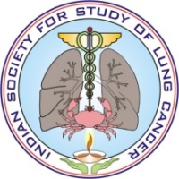 | 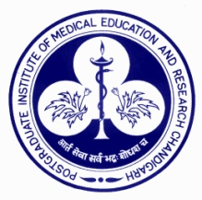 | 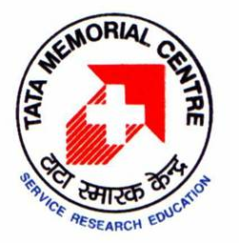

Registration Form

Name on Certificate/Badge: ___________________________________________
Department and Institute: ____________________________________________
Medical Council Registration Number (if applicable): _______________________
(MCI/State) with which registered: _____________________________________
Address for Correspondence: _________________________________________
_________________________________________________________________
________________________________ (6 digit) Pincode: __________________
Number 1) Landline:___________________ 2) Mobile:_____________________
Email id: 1) __________________________ 2) ___________________________

Payment Details*
Amount:___________________ Cheque/Draft No._______________________
Drawn on Bank:________________________________ Dated: _______________

* In case you wish to make the payment online via NEFT, please email us at 3rdLungMCMC@gmail.comand we shall send you the relevant details for the same

Registration Fee for the Course

All fees mentioned are in Indian Rupees and include 18% GST as per Govt of India regulations | Upto December 15, 2017 OR  Till First 75 registrations (whichever is earlier) | 15 December 2017 to  31 January 2018OR  Till First 150 registrations (whichever is earlier) | February 01, 2018 onwardsOR  151st registration onwards (whichever is earlier)
Postgraduate Students, Residents, Fellows and othersin training* | Rs. 1750/- | Rs. 2300/- | Rs. 2900/-
Physicians, Surgeonsand other health care professionals in practice | Rs. 2900/- | Rs. 3500/- | Rs. 4200/-
*For Post graduate students/residents/fellows, registration form should be accompanied by a certificate regarding status of being in-training from either the Director/Principal of the Institute or Head of Department in which he/she is enrolled

Kindly make multicity cheque or bank draft (payable at Chandigarh, India) in favor of
“ Lung Cancer Education Society ” [Outstation cheques will not be accepted]

Send your registration form and payment (by post or email) to

Office of Department of Pulmonary Medicine,Room No 17-A, Level IV, F Block, Nehru Hospital, PGIMER, Sector 12, Chandigarh, India–160012
Contact Details: +91-172-275-6820, 26, 28[Email: 3rdLungMCMC@gmail.com]

- Credit hours for the course will be applied for from Punjab Medical Council
- Registration fee includes lunches/refreshment breaks on both days and dinner on day 1
- Registration fee is non-refundable. However, under exceptional circumstances, requests for transfer of registration to a colleague shall be assessed on a case-to-case basis
- Receipt will be sent by e-mail at the email address(es) written on the registration form

